Building a Chatbot with UI in LangGraph & Streamlit
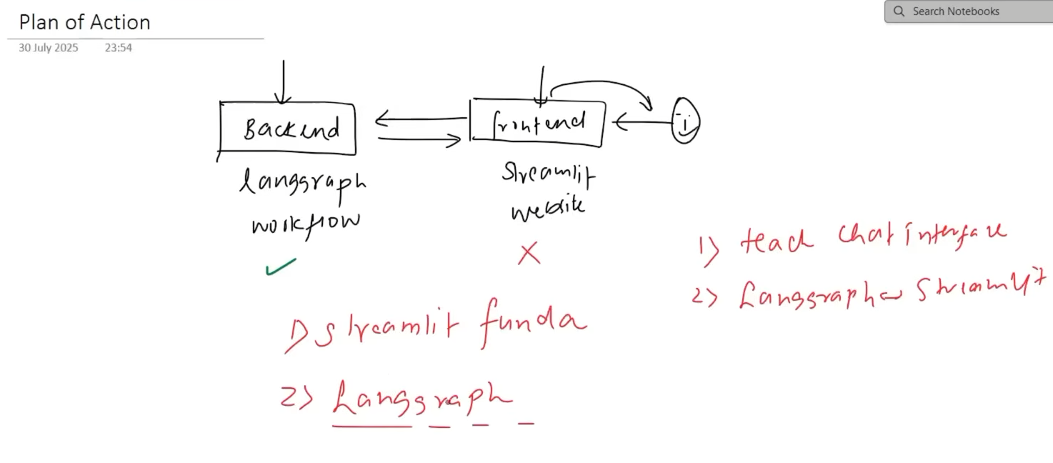

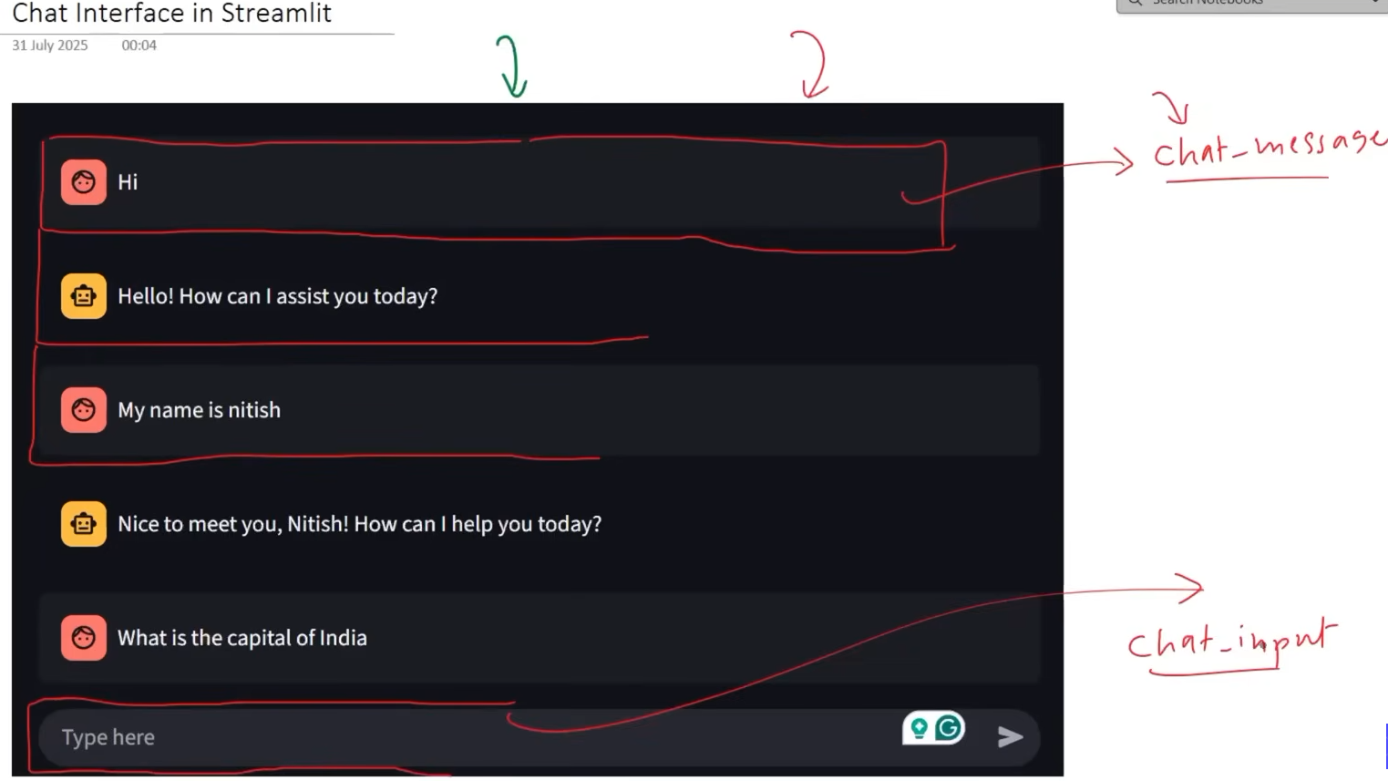
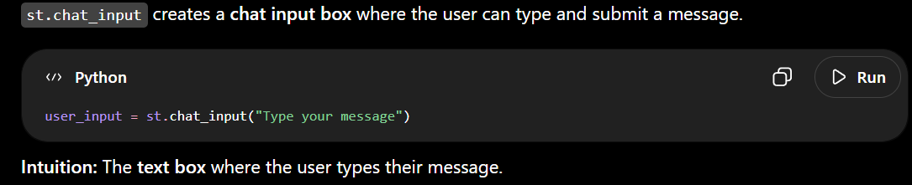
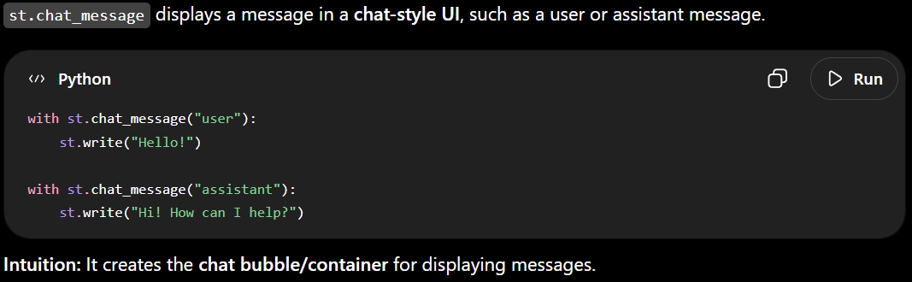
Code:-
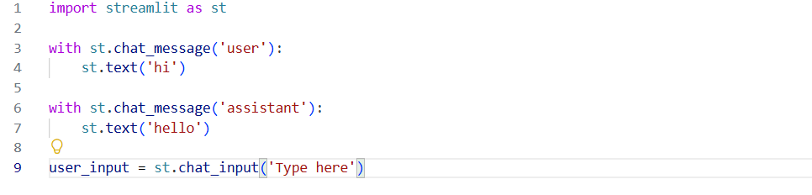
Result:-
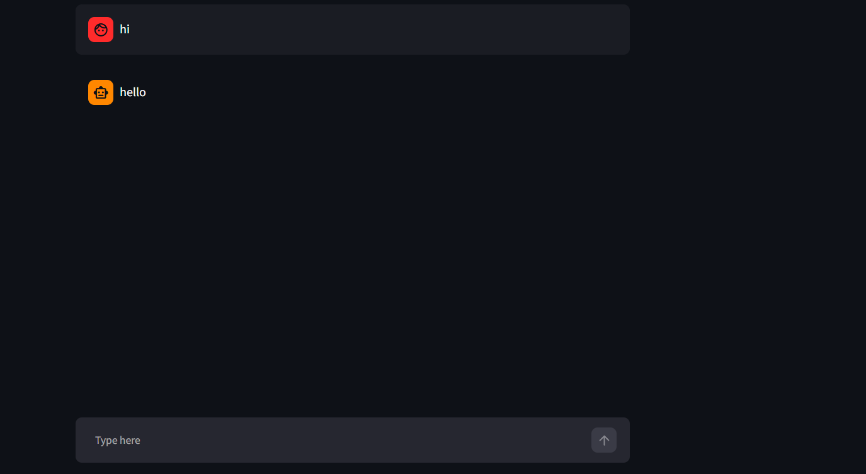

When we use st.chat_input() and press Enter, Streamlit reruns the entire Python script from top to bottom.
Because normal Python variables are recreated during every rerun, the previous chat history gets reset unless we explicitly store it somewhere persistent.
Intuition: Streamlit works like refreshing the page after every message. If the conversation isn't stored somewhere, the previous messages disappear.
We could use a normal list to store the chat history, but Streamlit reruns the entire script whenever we enter a message, so the list would be recreated and reset.
Streamlit provides a special dictionary called st.session_state that persists data across reruns during the same browser session.
Intuition: Think of st.session_state as a special storage space that survives Streamlit reruns. It is cleared when the session is reset/restarted.

Code:-
We import the chatbot from our langraph_backend file so the Streamlit frontend can use the LangGraph workflow. Since our chatbot uses a checkpointer for persistence, we also need to provide the config with a thread_id when invoking it.

st.session_state is the special dictionary provided by Streamlit that preserves data across reruns.
We check whether the message_history key already exists. If it doesn't, we create it and assign an empty list to store the chat messages.
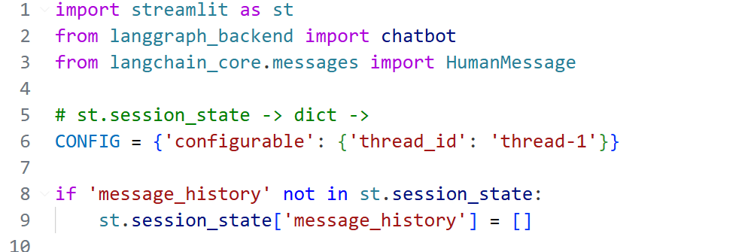
The first section is responsible for displaying all the previous messages stored in message_history.
Every time Streamlit reruns after a new message, this section runs again and displays the existing chat history.
Intuition: It re-draws the previous conversation on every rerun so the chat remains visible.
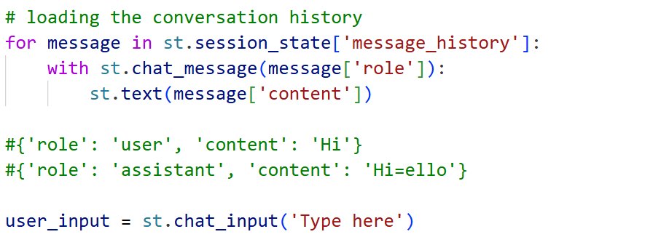
If user_input exists, we take the current user message and pass it to the chatbot. The chatbot processes it and returns the AI response, which we then display.
The previous chat history is displayed before this section, so every time Streamlit reruns, the old messages appear first and the current user input/AI response is shown after them.
Intuition: First show the old conversation, then process and show the new message.
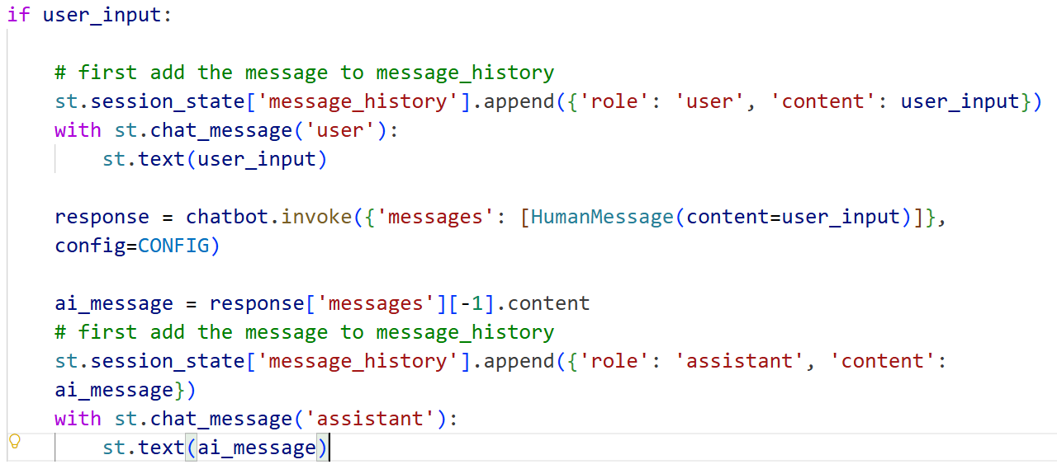
Result:-
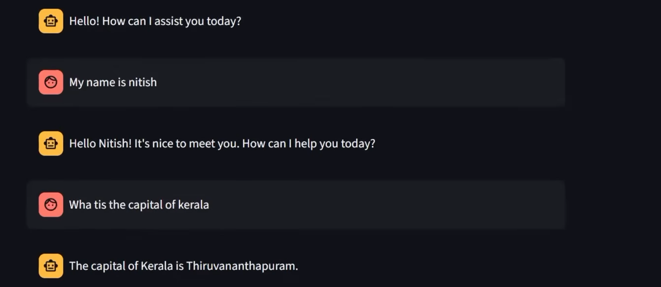

langgraph_backend.py
Code:-
